#OURSWIMSTORY, A NEW REPORT FROM THE BLACK SWIMMING ASSOCIATION IS SET TO LAUNCH IN WALES
THE CHARITY’S INSIGHTS AND RECOMMENDATIONS FOLLOW STATISTICS HIGHLIGHTING ALARMING DROWNING RATES IN ETHNIC MINORITY COMMUNITIES
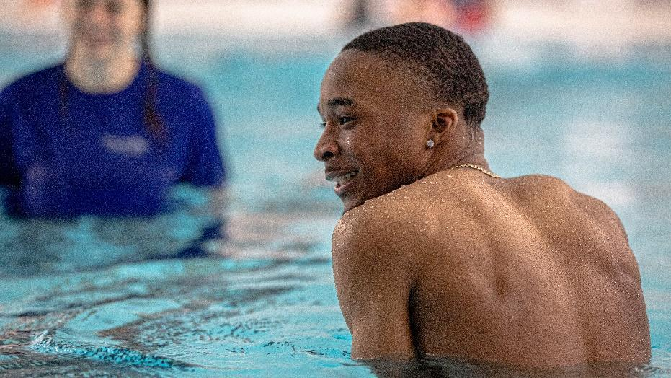
(NOVEMBER 7th 2023) The BSA is announcing the official launch of the organisation’s #OurSwimStory report in Wales. This will take place on the 7th of November 2023 at PwC, Cardiff. The launch follows a successful London launch event which took place in July 2023 at PwC, London. This also follows a significant roundtable discussion, also held in July 2023 at Number 10 Downing Street. The event saw key stakeholders and representatives from government bodies come together for a discussion in observance of World Drowning Prevention Day.*
#OurSwimStory was commissioned by The BSA in response to the underrepresentation of people of African, Caribbean and Asian heritage in swimming and aquatic activities. Their lack of vital water safety knowledge places these communities at high risk of drowning. For example, recent data from the National Child Mortality Database (NCMD) shares the very first capture of children who have drowned in England by ethnicity.* The database highlights a major disparity in drowning rates amongst children of Black and Asian heritage when compared to children of White or White British ethnicity.
#OurSwimStory is a landmark research project, which represents the voices of over 1,400 adults from Black, Asian and other ethnically diverse backgrounds, and highlights their experiences with water safety and aquatic activity. Notably, the research identified significant barriers to safe aquatic engagement and presented eleven recommendations aimed at increasing water safety awareness and aquatic participation. The findings underscore the urgent need for tailored interventions, community engagement, and collaboration to address the disparities in the UK and prevent drowning incidents effectively.
"The Black Swimming Association is honoured to be sharing our research insights via a second launch event in Wales," said Danielle Obe, Chair at the BSA. "It is crucial that we recognise the unequal and inequitable access to water safety knowledge and aquatic skills faced by Black and Asian communities in the UK and that we work together to eliminate these disparities. We know that our actions taken today will have a profound and lasting impact on generations to come.”
Taking place on the 7th of November 2023 at PwC, Cardiff, the launch event will serve as an opportunity to further highlight the tragic and profound impact of drowning on families and communities as well as offer life-saving solutions. 236,000 people drown worldwide each year, according to World Health Organization estimates and most of these deaths are preventable through evidence-based and cost-effective solutions. Such solutions include teaching school-aged children vital water safety and survival swimming skills and providing safe places away from water for preschool children.
In the spirit of collaboration, a selection of Welsh aquatic and lifesaving organisations, policymakers, and concerned individuals have been invited to join them in raising awareness and highlighting the issues identified in the #OurSwimStories report. Together, we can make a real difference and create a future where water safety and swimming are equitably accessible to all. Anyone can drown, no one should.

END

For media inquiries please contact:
GUNG HO Communications
Email: BSA@gunghoco.com

Note to editors:
About the Black Swimming Association (BSA):
The Black Swimming Association (BSA) is a non-profit organisation, set up to diversify the world of aquatics through consultancy, advocacy, research, education and support to ensure that people of African, Caribbean and Asian heritage have equitable, safe access to vital water safety education, drowning prevention and all the benefits of engaging in aquatics.
The BSA collaborates with a wide range of stakeholders, including government agencies, national governing bodies, lifesaving authorities, charities, sports councils, leisure operators, as well as research and educational institutions, in order to promote diversity and inclusion in aquatics for all communities. The BSA is the commissioning body of the pioneering research project #OurSwimStory, which investigated the attitudes towards, and the experiences of, water safety and aquatic activity among ethnically diverse communities in the UK.
High-resolution images and additional information about the Black Swimming Association and the "Our Swim Story" report are available upon request.

To find out more about the research #OurSwimStory please visit: https://thebsa.co.uk/ourswimstory/

To find out more about World Drowning Prevention Day please visit
https://www.who.int/campaigns/world-drowning-prevention-day/2023

*Recent data from the National Child Mortality Database d(NCMD) shares the very first capture of children who drown in England by ethnicity:
Black or Black British- 7.50 per million children
Mixed- 3.12 per million children
Asian and Asian British- 2.86 per million children
White or White British- 1.87 per million children

